QuArk Map Editor for Mahatta Tutorial

Hint Brushes

Hint brushes are used to split leaf nodes and generate more portals to make better visibility culling (removal). Defining hint brushes are easy. Using them correctly is the hard part. Bad placement of hint brushes will cause longer map compile time and even no performance gain at all.

First, create a simple hall with three rooms. Add at least one object in each room (to determine how effective the hint brushes are):

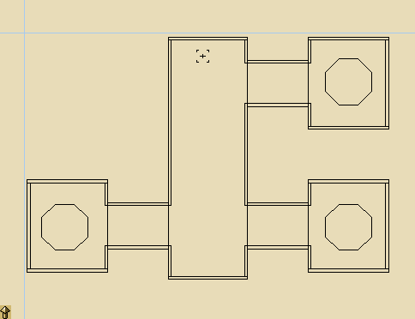

Remember to make room objects to detail brushes (furniture, etc.)

Compile the map and load the portal (Mahatta->Complete Rebuild, Mahatta->Load Portalfile).
You should see the portals as following:

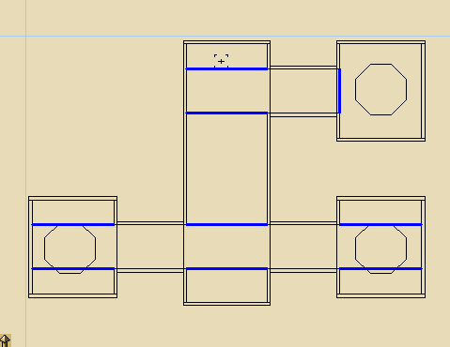

Remember how visibility is determined in Mahatta. The illustration below shows each leaf nodes in different shades (review from Explanation of Maps):

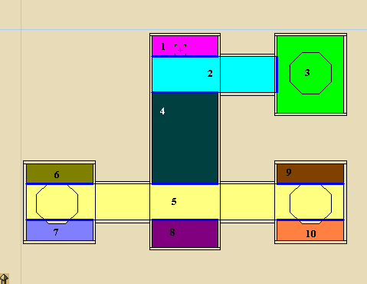

Standing on leaf node 1, you are able to see leaf node: 2, 3, 4, 5, 8. The two objects on leaf node 5 are rendered even if they are totally not visible. You can determine this by finding a line that can be drawn between each leaf node’s borders.

Load the map in Mahatta and set the scene FX to wireframe, you will clearly see.

The solution to this is to create more portals to divide leaf node 5 into smaller pieces so that the two objects can be culled.

We must first understand how to use the hint brushes. When you create a brush, you need to set its texture to “common/hintbrush”. Each side of the brush will split the nodes it touches. Take a look at how it affects a simple cube room.

Start a new map with the default cube room.

Compile the map and load its portal file. Take note of the portals.

Now, create a cube. Set its texture to “common/hintbrush”. Place the cube to the center of the room.

Compile the map and load its portal file. See how the hint brushes split the leaf nodes.

Example:

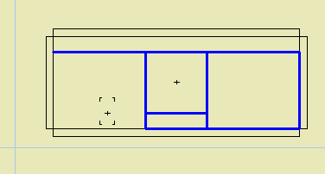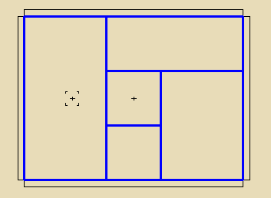
Now back to our previous map, we need to determine what leaf nodes to split, looking at the illustration with shaded leaf nodes, we want to split leaf node 5 into three nodes:

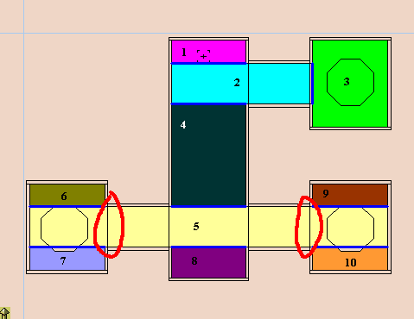

The red circles denote where we want to add portals.

Add a cube to the map and set its texture to “common/hintbrush”.

Re-size the cube so that it touches the floor, walls and ceiling. Then extend the x-axis sides to meet each room.

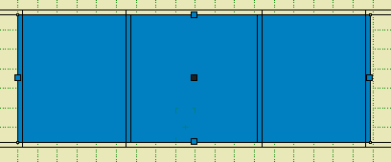

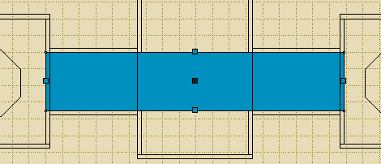

Re-compile (complete rebuild) the map and load its portal file.
The portals now consist of these:

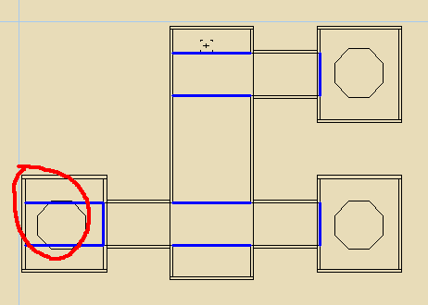

The red circle encapsulates the two unnecessary portals. We need to remove the redundant hint brush sides of the cube. We only want the two sides that touch both rooms.

To do this, we need to set the texture of the other sides to “common/skip”. What this texture does is that it tells the compiler to skip the side. This is so that we are only left with two hint brush sides.

Select the hint brush cube and set its texture to “common/skip”.

Select one of the sides that face the room as shown below:

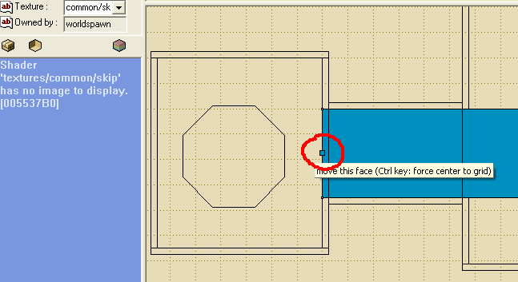
After you select the side, set its texture to “common/hint”.

Do the same to the opposite side.

Re-compile (complete rebuild) the map and load the portal file.

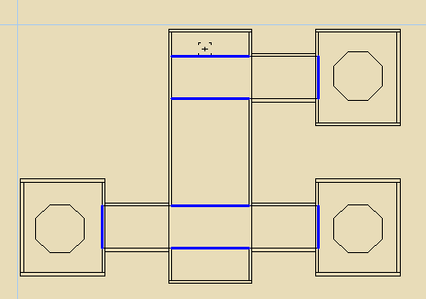

Standing at the start point, you will now be unable to see the contents of both rooms.

Load the map in Mahatta and you can see the difference with having hint brushes and not having them. (In Wireframe)

Let’s take a look at another case, a building with two floors. Here’s the side view of the map:

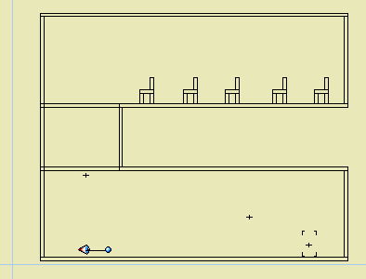

Compile the map and load the portal:

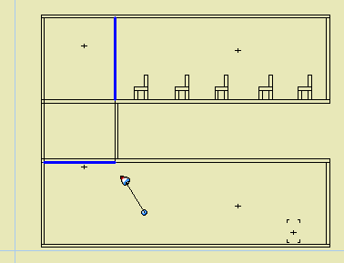

The problem with this is that both floors will be able to see each other. That means the furniture above will be rendered even if they are obviously not visible.
Create a cube and place it to the first floor as shown below:

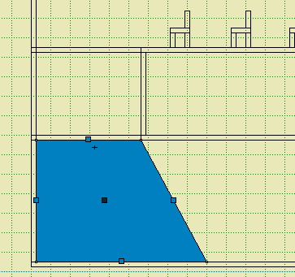

Set the cube’s texture to “common/skip” and set both side’s texture as show below to “common/hint”:

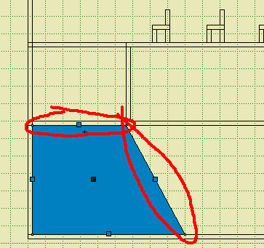
Do the same for the second floor, mirrored on the z-axis:

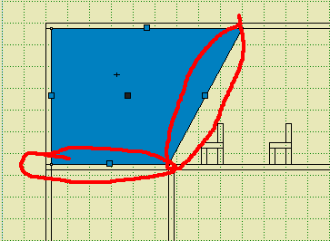

Re-compile (complete rebuild) the map.

Load the map in Mahatta and set the scene FX to wireframe. You won’t be able to see the furniture above in most of first floor.

Analyzing how this works, you can load the portal and visualize what each shaded leaf nodes can see:

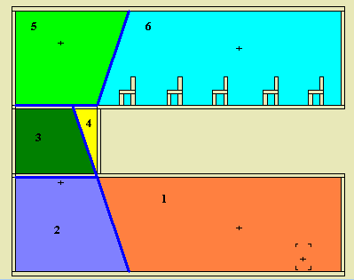

Standing in leaf node 1, you will only see leaf nodes 2, 3 and 5. You can determine this by finding a line that can be drawn between each leaf node’s borders.

Notes about using hint brushes:

You should ask yourself: “Is it worth the effort to block the room from visibility?”

The more hint brush you add, the more portals and leaf nodes there will be, thus increasing compile time. Make good use of hint brushes.

